First carpometacarpal joint
= trapeziometacarpal joint

Type
Saddle type of synovial joint

Articulating surfaces
- Articulating surfaces are reciprocally concavo-convex
- Imparts a wide range of mobility to the thumb

Ligaments
- Lateral, anterior and posterior ligaments
- Palmar and dorsal ligaments are oblique bands

Synovial membrane
Lines the joint capsule and is separate from it

Vascular supply
Radial artery and its first dorsal metacarpal branch

Innervation
Articular twigs from the posterior interosseous nerve

Joint movements
- Flexion is accompanied by medial rotation
- Full extension associated with slight lateral rotation
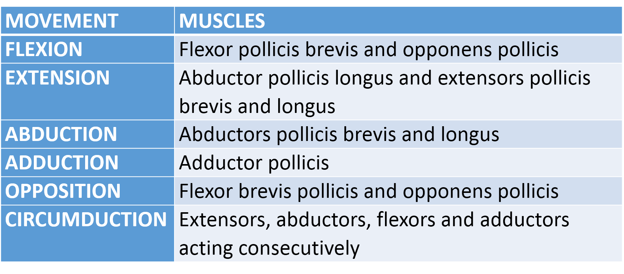
___MCQ_START___
Q1. Mark the wrong statement about first carpometacarpal joint
1. It is also called trapeziometacarpal joint
2. It is an ellipsoid joint[CORRECT]
3. It allows flexion and extension
4. It is supplied by radial artery
___
___MCQ_END____

